**TEST PLAN SCENARIO  
  
  
1. Target Website or Web Service**

URL: https://httpbin.org/

Endpoints to Test:

1. **GET** /get: Retrieve data without any input.  
   **GET** /status/200: Verify server response with HTTP 200 status.
2. **POST** /post: Send data to the server.

**a.LOAD TESTING**

* Number of Threads (Users): 50 users (simulating concurrent users).
* Ramp-Up Period: 30 seconds (users will be added gradually).
* Loop Count: 10 iterations per user.

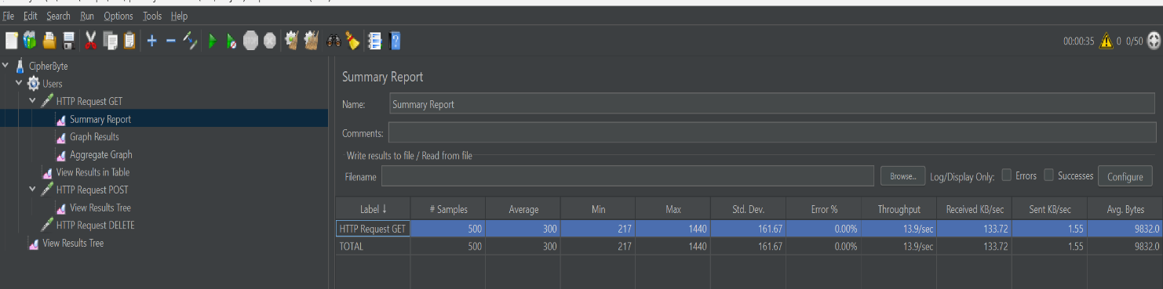

**b.STRESS TESTING**

* Number of Threads (Users): 500 (Simulate 500 users).
* Ramp-Up Period: 500 seconds (JMeter will add 1 user every 0 seconds until 500 users are reached).
* Loop Count: 10 (Each user will perform the actions 10 times).  
    
    
    
  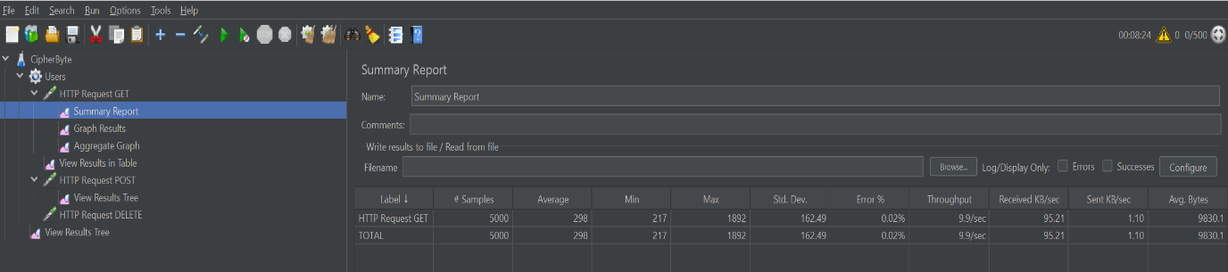
* Number of Threads (Users): 5000 (Simulate 5000 users).
* Ramp-Up Period: 500 seconds (JMeter will add 10 users per second).
* Loop Count: 10 (Each user will perform the actions 10 times).

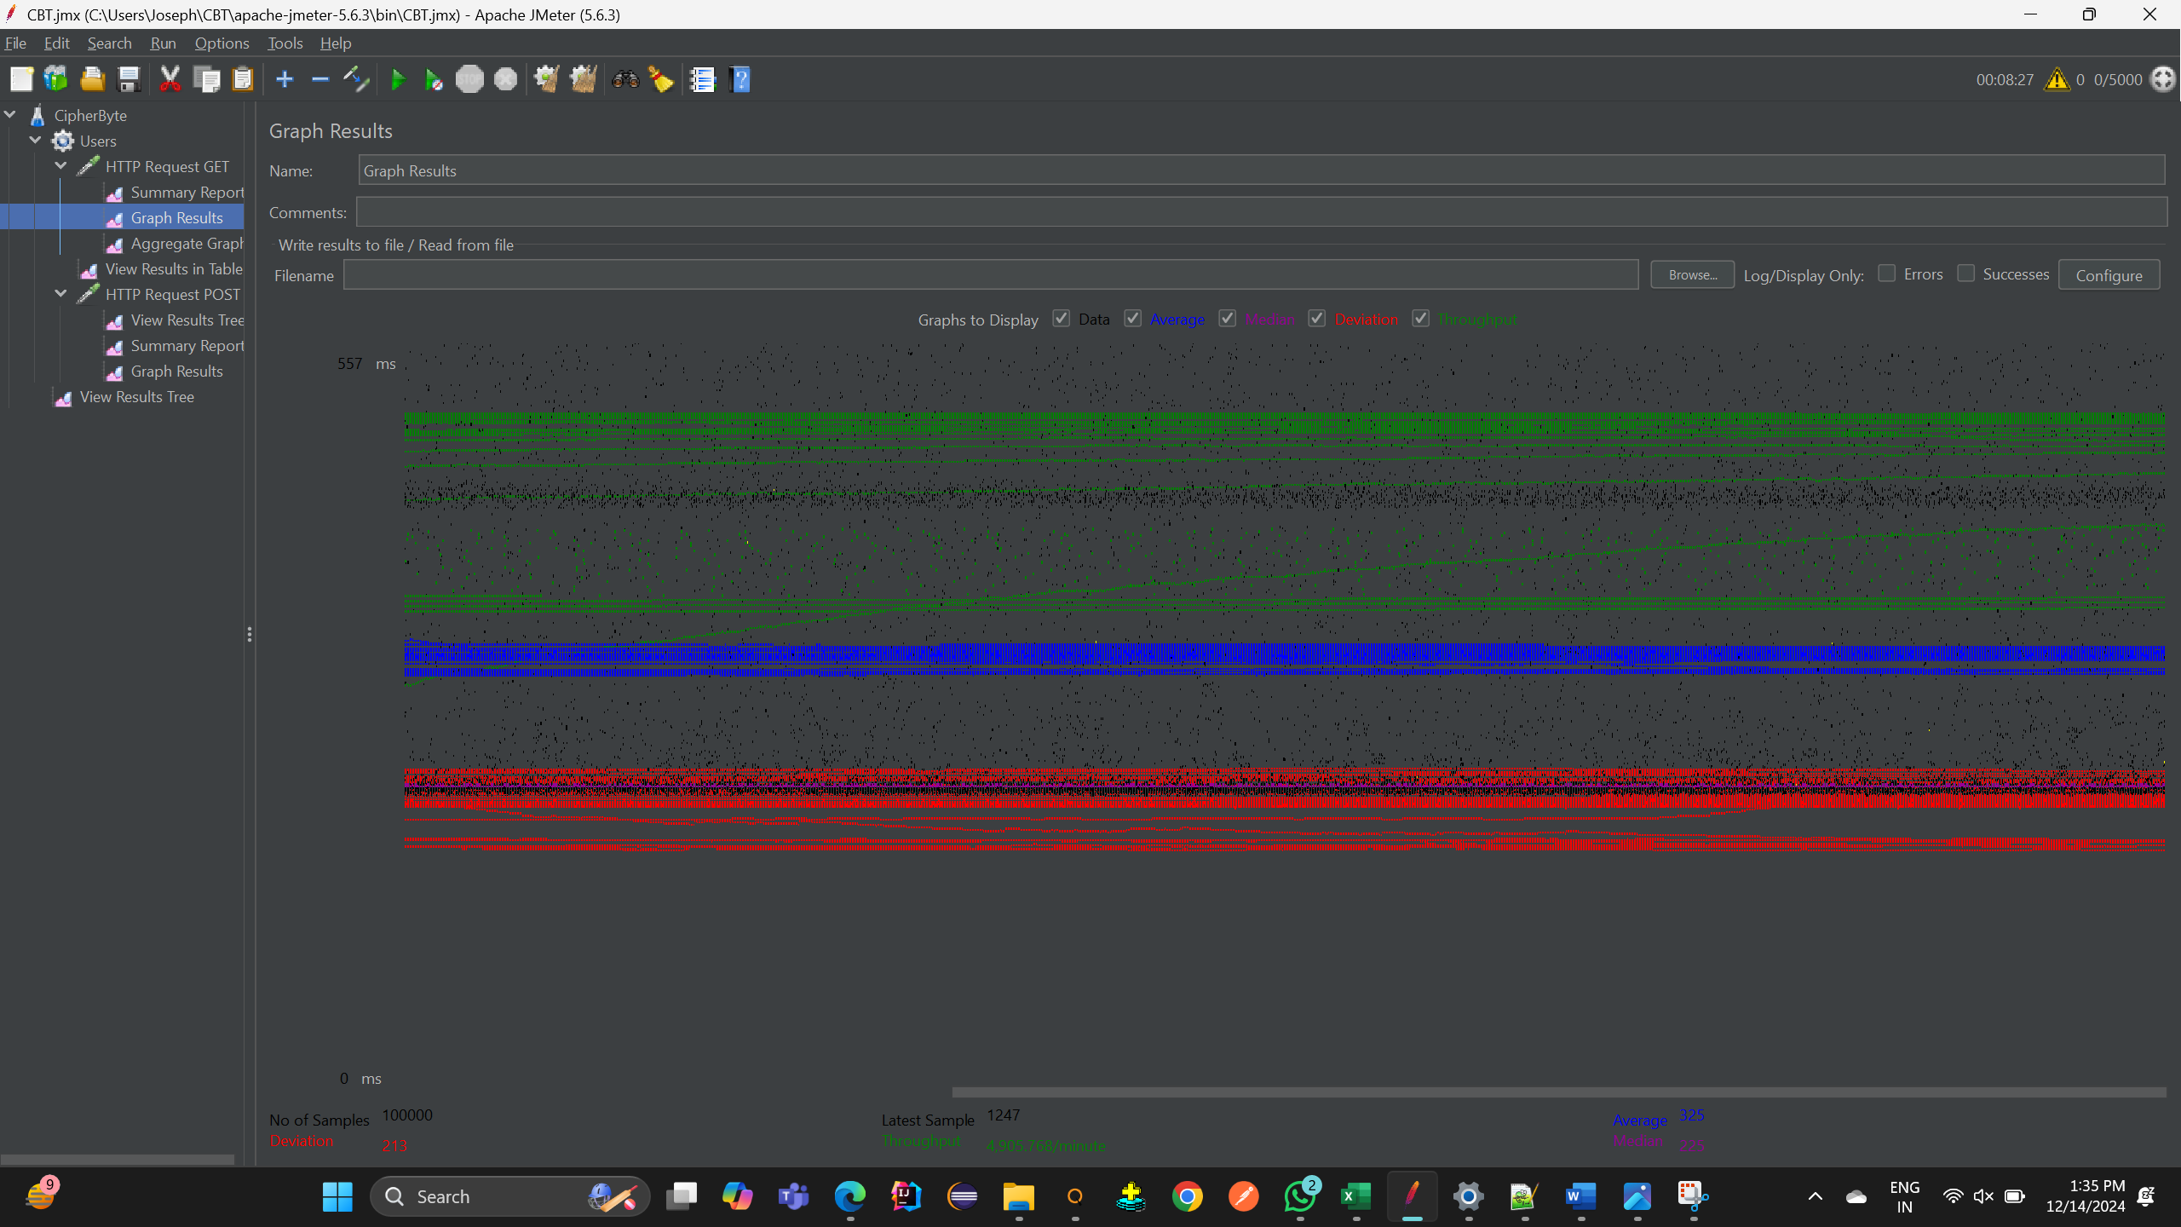

3**.DELETE**DELETE request is used to delete a resource from the server.  
 Server Name or IP: httpbin.org  
 Path: /delete

**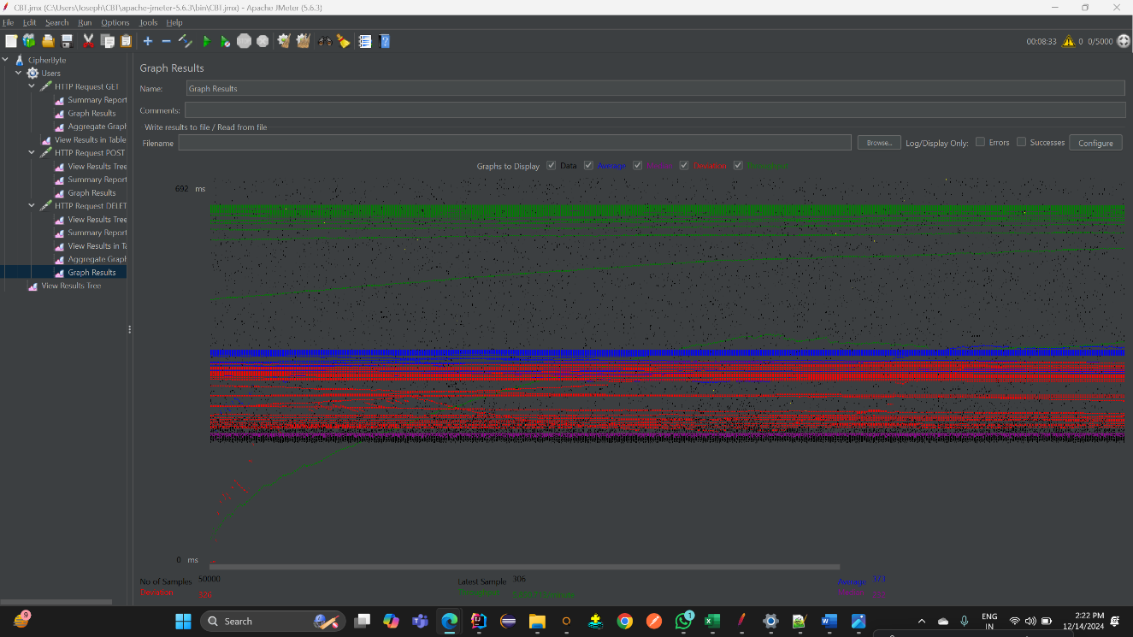  
  
  
  
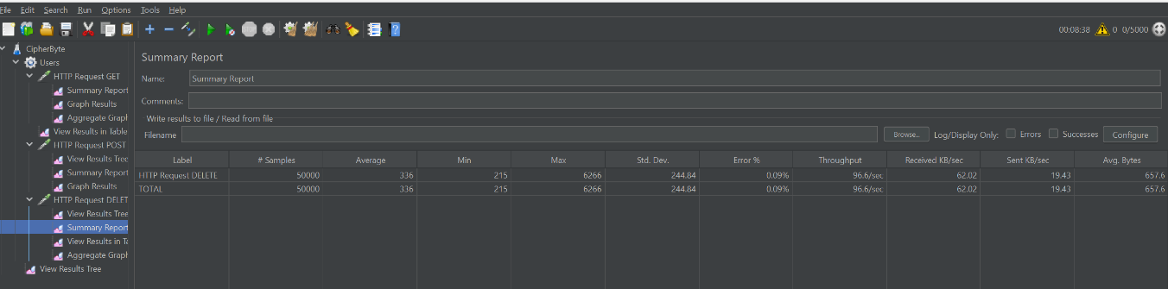**

4.**PUT** A PUT request is used to update or replace an existing resource Server Name or IP: httpbin.org

Path: /put 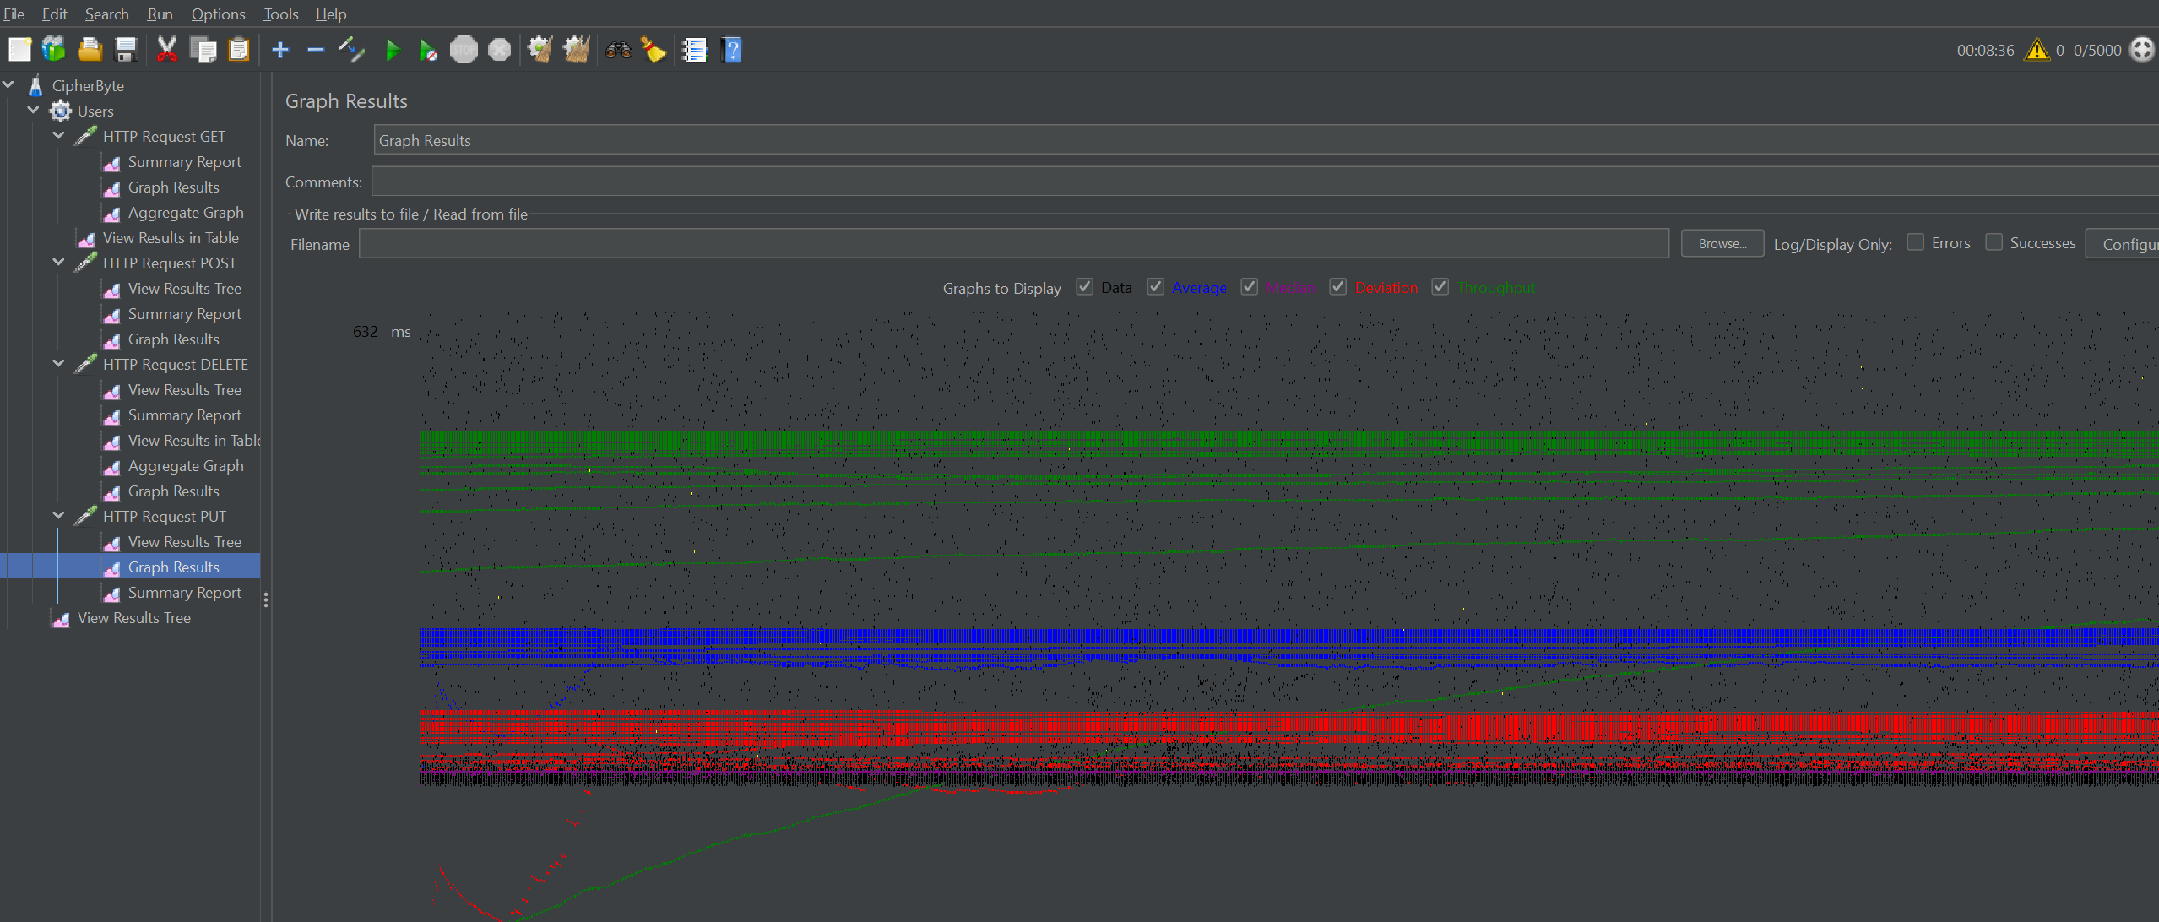  
  
  
  
**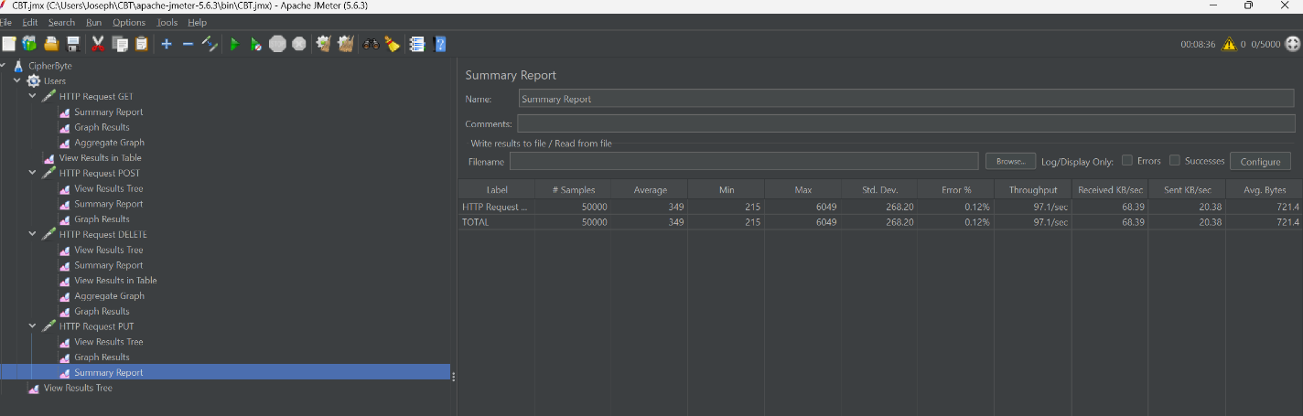  
4. Test Objectives**

Validate the website’s ability to handle concurrent user traffic.

Identify performance bottlenecks in the endpoints.

Ensure the server responds accurately and quickly under load.

**5. Tools and Resources**

Testing Tool: Apache JMeter.

System Under Test (SUT): Public website https://httpbin.org/.

Listener Reports:

Summary Report.

Aggregate Report.

Graph Results.

**6. Assumptions and Constraints**

The website is available and accessible.

Testing is limited to public endpoints; private APIs are excluded.

No authorization or authentication is required.